Malin Days Parade July 4th, 2021 – 11:00am
Theme: “175th Anniversary of the Applegate Trail”
REGISTRATION FORM

Name of Entry:_________________________________________________________
Description of Entry: ________________________________________________________________________________________________________________________________________________________________________________________________________________________________________________________________________________________________________________________________________________________________________________________________________
Name: _______________________________________________________________________________
Address: _____________________________________________________________________________
Categories: Best of Theme_______ Youth_______
Rules: The organizers of this parade do hereby disclaim any and all liability for accidents of any nature, whatsoever, and applicant(s) do hereby agree to hold the organizers harmless in any action resulting from such accidents. Children under the age of 18 years of age, who are not accompanied by their parent or guardian, must have the below participation form completed before entry.

My son/daughter (please print name)______________________________________ has my permission to participate in the Malin Days Parade.

Parent/Guardian’s Name: (please print name)____________________________________ Date:_______

Signature: ______________________________________ Phone Number: ________________________
Address:________________________________________________________ Date: _________________

Line-up for the parade starts at 10:00am in front of the Malin Grade School at 2153 3rd St. For more information contact Malin City Hall (541-723-2021) or Jana Dunlea (541-891-7981) or mail form to:
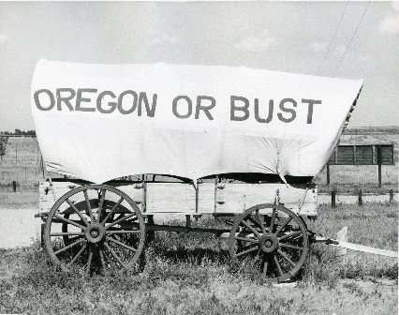
P.O. Box 61, Malin OR, 97632

